Name: ___________________________________ Date:__________
Ancient River Valley Civilizations DBQ Mrs. Valdes

Historical Context

Many early civilizations developed on deltas at the mouths of major rivers or in river valleys such as the Nile, Indus, Huang He and Tigris and Euphrates. Throughout the history of these civilizations, the one common factor has been the importance of these rivers. Living along rivers or at deltas has brought both prosperity and suffering to people.

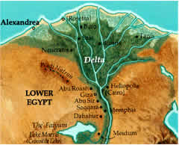
Task: After completing Part A, use the information from the documents, questions and your own knowledge of social studies to write an essay.
- Describe four (4) advantages and two (2) disadvantages to locating a civilization on a delta or in a river valley.

Part A
Document #1
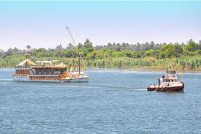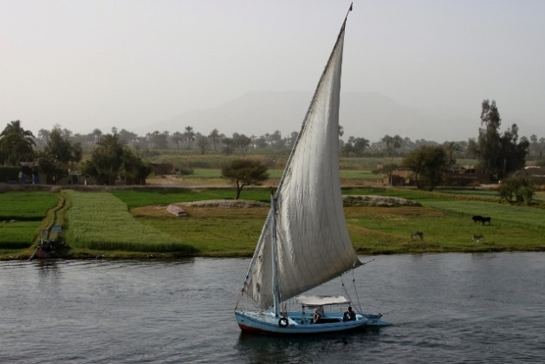

- According to the pictures, what were rivers used for? (1)
__________________________________________________________________________________________________________________________________________

- How did living along a river bring prosperity (wealth) to a civilization? (1)
_______________________________________________________________________________________________________________________________________________________________________________________________________________

Document #2
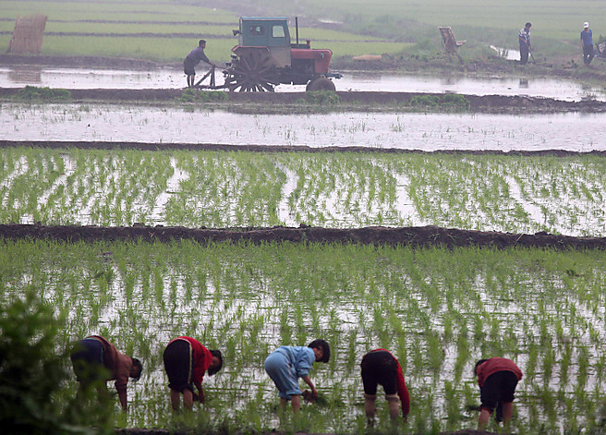
- What natural resources did rivers provide? (1)
_____________________________________________________________________________________________________________________________________________________________________________________________________________________
- Give one (1) example of how people used this resource. (1)
_____________________________________________________________________________________________________________________________________________________________________________________________________________________
- How did this natural resource contribute to the growth of civilizations? (1)
_____________________________________________________________________________________________________________________________________________________________________________________________________________________
Document # 3
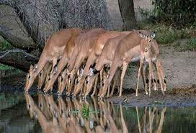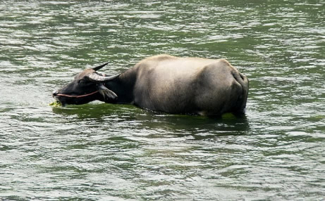
- Why were rivers important to animals? (1)
_____________________________________________________________________________________________________________________________________________________________________________________________________________________

- Give an example of why this would be an advantage to people? (1)
_______________________________________________________________________________________________________________________________________________________________________________________________________________

Document #4
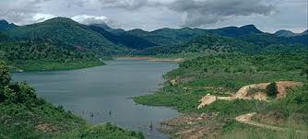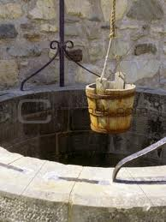
- What did rivers give people? (1)
_______________________________________________________________________________________________________________________________________________________________________________________________________________
- How did people use this natural resource? (1)
_______________________________________________________________________________________________________________________________________________________________________________________________________________

Document #5 – Clay found along river banks being made into bricks
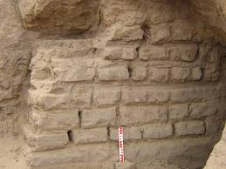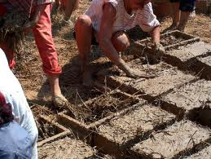
- The above examples depict (show) a product provided by rivers. What is the natural resource that is produced by a river? (1)
______________________________________________________________________________________________________________________________________________

- How did people use this natural resource? (1)
_____________________________________________________________________________________________________________________________________________________________________________________________________________________

Document #6
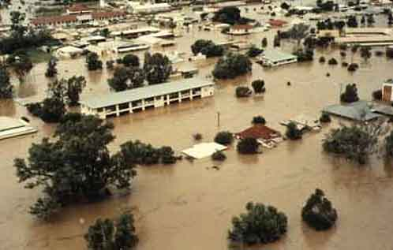
- What would be a disadvantage to living along a river? (1)
____________________________________________________________________________________________________________________________________________________________________________________________________________________________________________________________________________________

Document #7
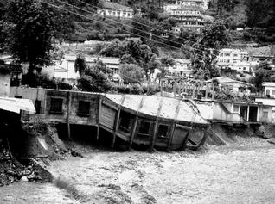
- According to the picture, what would be a disadvantage to areas that border a river? (1)
___________________________________________________________________________________________________________________________________________________________________________________________________________________________________________________________________________________________________________________________________________________________________

Document #8

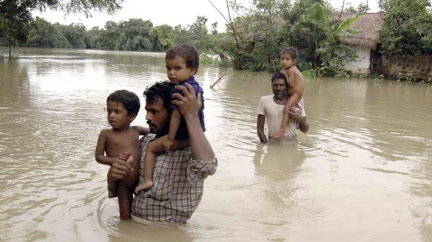
- How would people be negatively affected by living along a river? (1)
_________________________________________________________________________________________________________________________________________________________________________________________________________________________________________________________________________________________________________________________________________________________________________________________________________________________________________________________________________________________________________

Possible Answers to Documents
Document #1:

1. The rivers are used for transportation.

2. By living along a river, people traded which brought prosperity (wealth) to a civilization.

Document #2:

3. A natural resource that rivers provide is silt or rich soil.

4. People used this natural resource for farming/agriculture/growing crops.

5. Silt or rich soils enable (help) people to grow a surplus (extra) food. Surplus food created job specialization.

Document #3:

6. Rivers provided drinking water for animals.

7. Providing water for animals would be an advantage because people could have a food supply.

Document #4:

8. Rivers gave people water for crops, drinking, and bathing.

9. People built irrigation ditches to water their crops and wells to get drinking water.

Document #5:

10. The natural resource provided by rivers is clay.

11. People used clay to make bricks which were used to build structures (homes, temples…).

Document #6:

12. A disadvantage to living along a river would be flooding.

Document # 7:

13. A disadvantage would be land erosion.

Document # 8:

14. People could be negatively affected by losing their homes and becoming homeless.

Part B:
Many early civilizations developed on deltas at the mouths of major rivers or in river valleys such as the Nile, Indus, Huang He and Tigris and Euphrates. Throughout the history of these civilizations, the one common factor has been the importance of these rivers. Living along rivers or at deltas has brought both prosperity and suffering to people.

TASK:

Describe four (4) advantages and two (2) disadvantages to locating a civilization on a delta or river valley.

After completing PART A, use the information from the documents, questions and your own knowledge of global history to write an essay.

Remember a proper essay has an introduction, several body paragraphs and a conclusion. Please write in complete sentences and paragraph form.

Graphic Organizer
- Place the document number next to the example (doc _ )
ADVANTAGES | DISADVANTAGES
- (DOC _ )

- (DOC _ )

- (DOC _ )

- (DOC _ )

Graphic Organizer
- Place the document number next to the example (doc _ )
ADVANTAGES | DISADVANTAGES
1. (DOC 1 )  The rivers were used for transportation and trade. Trade makes civilizations wealthy (rich) | 1. (DOC 6)  A disadvantage to living along a river would be flooding.
2. (DOC 2 )  A natural resource that rivers provided was silt or rich soil.  People used the silt for farming/growing crops/ agriculture  Silt made the soil fertile which enabled (helped) people to grow surplus (extra) food. Food surpluses created job specialization. | 2. (DOC 7)  A disadvantage would be erosion of land.
3. (DOC 3 )  Rivers provided water for animals. This would be an advantage for humans because people would have a food supply. | 3. (DOC 8)  People would be negatively affected by flooding rivers because they could lose their homes and become homeless.
4. (DOC 4)

Rivers gave people water for drinking, bathing and watering crops. People built wells and irrigation canals.
5. (DOC 5)

The rivers provided clay which people made into bricks and used the bricks to build permanent structures.
Secret Tips for Writing a DBQ
ALL ESSAYS HAVE AN INTRODUCTION, BODY AND CONCLUSION

Hint: Borrow as much as you can from the Historical Context
Historical Context

Many early civilizations developed on deltas at the mouths of major rivers or in river valleys such as the Nile, Indus, Huang He and Tigris and Euphrates. Throughout the history of these civilizations, the one common factor has been the importance of these rivers. Living along rivers or at deltas has brought both prosperity and suffering to people.

Your thesis statement (1st sentence) can be:

On deltas or in river valleys many early civilizations developed.
OR
The civilizations of the Nile, Indus, Huang He and Tigris and Euphrates all started along rivers.

Your second (2nd) sentence can be:

The common factor among early civilizations have been the rivers.
OR
The importance of the rivers has been the one common factor throughout the history of civilizations.

Your third (3rd) sentence can be:

The rivers have brought richness and poverty to people.
OR
Suffering and prosperity is brought by living along rivers.

Model of Introduction Paragraph

On deltas or in river valleys many early civilizations developed. The common factor among these civilizations has been the rivers. The rivers have brought riches and poverty to people.

Or

The importance of the rivers has been the one common factor throughout the history of civilizations. The civilizations of the Nile, Indus, Huang He (Yellow River) and Tigris and Euphrates (Mesopotamia) all started along rivers.

Secret Tips for Writing a Body Paragraph for Your DBQ Essay

- Remember to indent your paragraphs or skip a line between paragraphs.
- Look at and use the information you wrote down in your graphic organizer.
Example:

An advantage of locating a civilization next to a river would be ___________________.(doc.__) It would bring prosperity or riches to people by ____________________. (doc. __) A second advantage of locating a civilization along a river would be the natural resource _______________.(doc. __) It would be an advantage because ________________________. (doc. ___) A third advantage of locating a civilization by a river would be __________________________________. (doc. __) This advantage provided people with ______________________. (doc. __) The fourth advantage was ____________________________. (doc. __) This helped the people by ___________________________. (doc. __)
Model Second Paragraph Using Examples From the Graphic Organizer
“Advantages of Locating a civilization near a river”

An advantage of locating a civilization next to a river would be transportation. (doc. 1) It would bring prosperity or riches to people by trading. (doc. 1) For example, Egypt is a civilization that became rich by trading with other civilizations such as the Mesopotamia. A second advantage of locating a civilization along a river would be the natural resource of silt. (doc. 2) An example of how ancient people used this natural resource was by growing crops. (doc.2) The silt allowed these civilizations to have an agricultural surplus or extra food. A third advantage of locating a civilization by a river would be having enough water for drinking and watering crops. (doc. 4) People who lived along the rivers were able to build irrigation canals to water their crops. (doc. 4)

Model Third Paragraph Using Examples From the Graphic Organizer

“Disadvantages of locating a civilization near a river”

